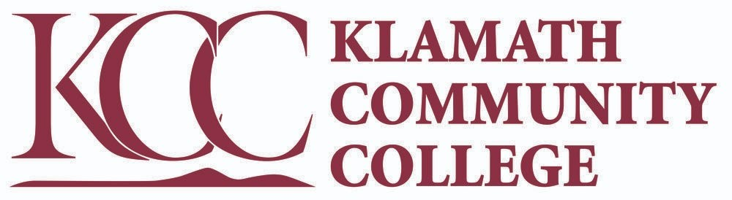
CARES Act Student allocation and benefit distribution process Spring Term 2020

Based On Validated Title IV Eligibility
-If current FAFSA on file OK
-If not on file, student can file for either 2019-20 or 2020-21 to show title IV eligibility

Award determination based on point system:
Points towards award
1 | Enrolled in 6-8 credits
2 | Enrolled in 9-11 credits
3 | Enrolled in 12+ credits
1 | Enrolled in BIO 234 or CHE or BIO 103
1 | Was enrolled in WLD, AMT, AVS, CUA
1 | Graduate of KCET GED program

Points
1 | $250
2 | $350
3 | $450
4 or more | $550

Points | Count | Award | Total
0 | 67 | 0 | 0
1 | 144 | 250 | $36,000
2 | 125 | 350 | $43,750
3 | 398 | 450 | $179,100
4 or more | 67 | 550 | $36,850
 | TOTAL: 734 | INITIAL  DISBURSEMENT  TO STUDENTS  (May, 2020) | $295,700

CARES Act Student allocation and benefit distribution process Summer Term 2020

Based On Validated Title IV Eligibility
-If current FAFSA on file OK

Award determination based on point system:
Points towards award
1 | Enrolled in 6-8 credits
2 | Enrolled in 9-11 credits
3 | Enrolled in 12+ credits
5 | Received a Pell Award in Summer 2020
1 | Enrolled in AMT, AVS, CUA
1 | Graduate of KCET GED program

Points
0-5 | No award
6 or more | 245 or 246*
* students were randomly selected between $245 and $246 to have 163 awards of $245 and 57 awards of $246 to award out the balance of the funds.

Points | Count | Award | Total
0-5 | 112 | 0 | 0
4 or more | 220 | 245 or 246* | $53,957
 | TOTAL: 220 | DISBURSEMENT  TO STUDENTS  (July 2020) | $53,957

CARES Act Student allocation and benefit distribution process Winter Term 2021

Based On Validated Title IV Eligibility
Award based upon Pell award for the Winter 2021 term

Award determination based on point system:
Points towards award
5 | Enrolled degree seeking and awarded 1,950 or more in Pell Award
4 | Enrolled degree seeking and awarded between 1,700 and 1,949 in Pell Award
3 | Enrolled degree seeking and awarded between 1,250 and 1,699 in Pell Award
2 | Enrolled degree seeking and awarded between 505 and 1,249 in Pell Award
1 | Enrolled degree seeking and awarded less than 505 in Pell Award

Points
1 | $450
2 | $525, $532, $540, $550
3 | $600
4 | $675
5 | $750

Points | Count | Award | Total
1 | 38 | 450 | $17,100
2 | 130 | 525 | $68,250
2 | 1 | 532 | $532
2 | 5 | 540 | $2,700
2 | 3 | 550 | $1,650
3 | 106 | 600 | $63,600
4 | 19 | 675 | $12,825
5 | 244 | 750 | $183,000
 | TOTAL: 549 | DISBURSEMENT  TO STUDENTS  (March, 2021) | $349,657

The variation of distribution for 2 points came from students 2 points who late dropped courses and were disqualified from receiving aid. Since awards had already been set, the redistribution of extra funds was randomly distributed to 9 students inside of the 2 point range.
CARES Act Student allocation and benefit distribution process Fall Term 2021

Based On all students impacted by disruption in learning due to COVID

Award determination based on enrollment status components for academic credit students:
Amount towards award:
400 | Fulltime enrollment and received Pell award
300 | Three-quarter time enrollment and received Pell award
250 | Half time enrollment and received Pell award
200 | Less than half time enrollment and received Pell award
350 | Recipient of an ORSA award
350 | Fulltime academic enrollment
250 | Three-quarter time enrollment
200 | Half time enrollment
150 | Less than half time enrollment
150 | Received a Pell award of greater than $1,500
200 | Within 20 credits of earning an associates degree
350 | Earned a GED through studies at KCC GED programing at KCET or HEP
126 | Enrolled in a Math class requiring additional homework software Algebra and higher
45 | Enrolled in a Math class requiring additional homework software below Algebra
High school students enrolled in college academic classes did not qualify for award
Total award was the greater amount of either the sum of the above qualification by individual student or 55% of the student’s academic credit tuition portion of their bill.

Award determination based on enrollment status components for Adult Learning GED/ESL students enrolled at KCC’s KCET and/or HEP programming:
Amount towards award:
500 | Term enrollment in 66 or more clock hours of GED/ESL instruction
350 | Total student lifetime enrollment in GED/ESL instructions of 200 or more hours

Award determination based on enrollment status components for non-credit workforce students:
Amount towards award:
500 | Enrolled in a non-credit workforce class where tuition/fee was not paid by student’s employer and tuition and fee cost was greater than $500

Count | Award | Total
360 | 1-500 | 137,778
552 | 501-1,000 | 435,646
176 | 1,001-1,500 | 199,554
2 | 1,501-2,000 | 3,476
TOTAL: 1,093 | DISBURSEMENT  TO STUDENTS  (December, 2021) | 782,987

CARES Act Student allocation and benefit distribution process Winter Term 2022

Based On all students impacted by disruption in learning due to COVID

Award determination based on enrollment status components for academic credit students:
Amount towards award:
550 | Fulltime enrollment and received Pell award
450 | Three-quarter time enrollment and received Pell award
400 | Half time enrollment and received Pell award
350 | Less than half time enrollment and received Pell award
500 | Recipient of an ORSA award
500 | Fulltime academic enrollment
400 | Three-quarter time enrollment
350 | Half time enrollment
300 | Less than half time enrollment
310 | Received a Pell award of greater than $1,500
350 | Within 20 credits of earning an associates degree
500 | Earned a GED through studies at KCC GED programing at KCET or HEP
High school students enrolled in college academic classes did not qualify
Total award was the greater amount of either the sum of the above qualification by individual student or 70% of the student’s academic credit tuition portion of their bill.

Award determination based on enrollment status components for Adult Learning GED/ESL students enrolled at KCC’s KCET and/or HEP programming:
Amount towards award:
600 | Term enrollment in 66 or more clock hours of GED/ESL instruction
400 | Total student lifetime enrollment in GED/ESL instructions of 200 or more hours

Award determination based on enrollment status components for non-credit workforce students:
Amount towards award:
550 | Enrolled in a non-credit workforce class where tuition/fee was not paid by student’s employer and tuition and fee cost was greater than $550
variable | Amount equal to tuition and course fees paid by the student for courses in a non-credit workforce class where tuition/fee was not paid by student’s employer and tuition and fee cost was less than or equal to $550

Count | Award | Total
173 | 1-500 | 54,939
457 | 501-1,000 | 369,659
307 | 1,001-1,500 | 384,250
120 | 1,501-2,000 | 202,150
8 | 2,001-3,000 | 18,110
TOTAL: 1,065 | DISBURSEMENT  TO STUDENTS  (February, 2022) | 1,029,108

