through

Greetings,
Hope this school year is treating you well. With winter term fast approaching, I wanted to provide you with some key information.
First, I would like to take this opportunity to introduce you to the newest member of our Accelerated Learning team. Anna Malone has joined us as our brand-new Accelerated Learning Student Success Advisor. Anna is a KCC alumni and will graduate from Oregon Tech this spring 2023. With Anna’s current college experience, she will be able to offer advising with firsthand knowledge. This means that we will still be able to continue to expand and offer the concierge of specialized services that we started with during 2021-2022.
Please note:
Accelerated Learning Department has moved! We are now in building #4
Kelly Kandra – Accelerated Learning Director is now in room 414D
Anna Malone – Accelerated Learning Student Success Advisor is now in room 414E.
We are across the hall from Career Services.
A secure drop box is located outside of our office doors which will allow students to pick up and drop off, registration forms and drop/withdrawal forms.
Below is a breakdown of information that you will find useful as you work through the process of enrolling students into KCC courses.
- Highschool Connection Website
  - Takes you to Accelerated Learning Website
- Placement Testing and Scheduling
- Difference between Course Types
- Registration and FERPA
- Underage Enrollment Packet
- Courses without Pre-requisites
- The Importance of CGS100 course
- Degrees, Pathway Certificates and Apprenticeship Programs
- Drop/Withdraw Process
- Articulation Agreements
- Bookstore Information
- Standards of Satisfactory Academic Progress (SAP)
- Student Appeal for High School Students
- Important Reminder
Important & Frequently Visited Links:
    - High School Connection website: https://www.klamathcc.edu/Admissions/High-School

    - Catalog 2022-2023: https://catalog.klamathcc.edu/

    - Degree and Certificate Programs: https://catalog.klamathcc.edu/content.php?catoid=14&navoid=914

    - Course Descriptions: https://catalog.klamathcc.edu/content.php?catoid=14&navoid=915

    - Academic Calendar: https://catalog.klamathcc.edu/content.php?catoid=14&navoid=905

    - MyKCC: https://mykcc.klamathcc.edu/ics

    - Current Course Schedules: https://mykcc.klamathcc.edu/ICS/Academics/Fall_term_schedules.jnz

    - Oregon Promise opportunity: https://www.klamathcc.edu/en-US/Admissions/FYE/Oregon-Promise

    - Counselor Resources tab (burgundy box)-Your go-to Tab! https://www.klamathcc.edu/Admissions/High-School/High-School-Connections

HIGH SCHOOL CONNECTION WEBSITE:
https://www.klamathcc.edu/Admissions/High-School
Click “High School Professionals” (burgundy box).

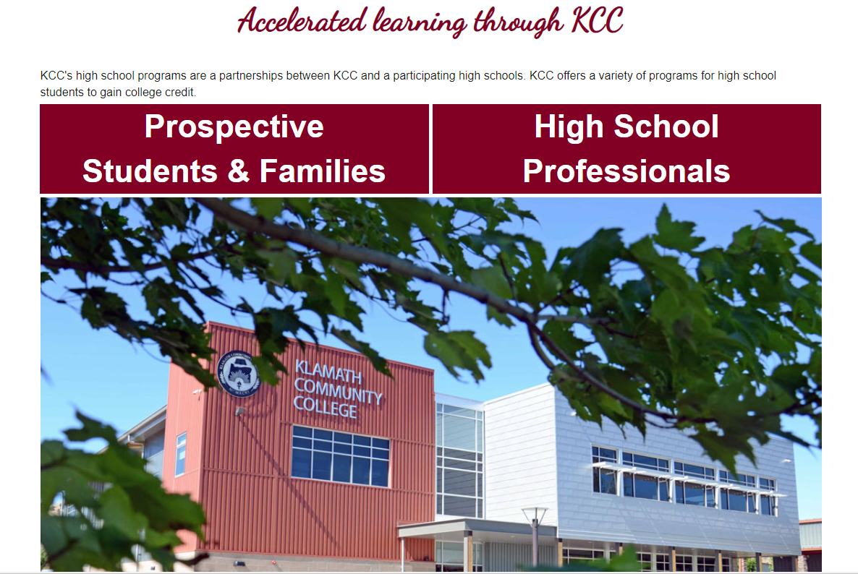

Listed are forms and information on how to schedule a KCC campus tour in-person or virtually, registration forms, academic programs, student resources and several other resources to assist YOU as a high school counselor and high school students.
Counselor Resources tab (burgundy box)- Your go-to Tab!
https://www.klamathcc.edu/Admissions/High-School/High-School-Connections
Important: Listed are specific links to information and documents to Drop/Withdrawal courses, Registration forms, Student Handbook, Academic Calendar, Course Catalog, Underage Process, Student Appeal Process, Testing Center, Tutoring Center, Library, how-to access unofficial transcripts, MyKCC information, High School Discount Rate Information and several other helpful resources.

PLACEMENT TESTING & SCHEDULING:
New Student?: The student will need a student ID to be able to schedule placement exams. Please email, or call with the following information to Accelerated Learning to generate a student ID.
Student Name:
Address:
Cell phone#:
Student personal email address—not the parents:
DOB:

Writing Placement- Schedule through the testing center; Telephone: 541.880.2334
Math Placement- Contact Anna Malone at 971-380-5132 for questions regarding math placement testing. To pick up a math placement test stop by building 4, Room 414E and talk to Anna.
All placement exam results need to be saved and emailed to Anna Malone at malone@klamathcc.edu, or drop-off at the Accelerated Learning department, building 4, room 414E.

DIFFERENCE BETWEEN COURSE TYPES & SCHEDULE:
Course Type:

DE- Distance Education: Instruction where the student interacts with the instructor and other students using Canvas. There are no meetings on campus, but completion of regular assignments with due dates is required. Lectures and other videos may be included on Canvas.

HX- HyFlex: HyFlex courses include distance delivery and in-person instruction. Students choose how they participate in the course and engage with material in the way that works best for them from session to session. Completion of regular assignments with due dates is required. Lectures may be included and recorded.

M- Military: Military courses have more credits than traditional courses. Example: WRI121M.01 is 5 credits compared to WRI121.01 is 4 credits.

H- Hybrid: A hybrid course includes both contents delivered via Canvas and in-person instruction. All students in a hybrid course are required to complete the combination of remote and in-person activities as assigned.

Textbook Information listed next to course (in course schedule):
Days of the Week:
M Monday S Saturday
T Tuesday U Sunday
W Wednesday
R Thursday
F Friday

NC = No Cost Textbook
LC = Low Cost Textbook

REGISTRATION & FERPA:
Check-List:
- Age- If Student is 16-years old or older proceed to the next step. If student is younger than 16, please refer to UNDERAGE ENROLLMENT PACKET.

- Previous Completed Courses from another College and/or University- Please email unofficial transcripts to Accelerated Learning. Completed courses from another college/university could fulfill the prerequisite requirement for certain KCC courses.

- Placement Testing- Student needs to complete placement testing? Refer to PLACEMENT TESTING & SCHEDULING.

- FERPA Form- Student must complete FERPA form. The FERPA form must include their high school information, so KCC is able to release specific information to high school. Parent information must be included on the FERPA form in order for KCC to release specific information to parents. Note: BE SURE THE STUDENT INITIALS NEXT TO EACH TYPE OF RECORD/INFORMATION (NO check marks) on FERPA form.

- Select courses- Check the courses in the catalog to see if there are any prerequisites required.

- Complete Registration Form- Please review important steps in Registration Specifics below.

- Submit Completed Registration form, FERPA form, Placement Exam results, unofficial transcripts from previous school (if applicable) to Accelerated Learning.

- Connect to MyKCC

- Get Started on FREE Canvas Training Course.

Registration Specifics:
- Registration forms must be completed by typing to ensure the information is clear and easy to read.

- Fill in the complete course with course section (.01), and DE if the course is distance education. For example, WRI 121. 01 DE. Please refer to DIFFERENCE IN COURSE TYPES & SCHEDULE to understand the differences in DE, M, H, HX.

- If a student is registering for a course with KCC for the first time, they will be enrolled in a FREE Canvas Training Course. If the high school student is already familiar with Canvas, they will not need to complete the course. Canvas is the learning platform used by KCC instructors, it’s critical a student knows how to navigate through Canvas prior to the start of the term. Please be sure this course is complete before the term begins.

- Student must connect to student email by visiting MyKCC: https://mykcc.klamathcc.edu/ICS/ . (MyKCC Guide attached for step-by-step to get connected).

If a student has taken prior courses with KCC they will most likely already be able to log into their MyKCC account. If you have a student that does not remember their student ID, contact Accelerated Learning. Ensuring that a student can log into their MyKCC account and see that they have been enrolled into the course/s is important and should be done prior to the term. Recommendation is to check a few days after registration form has been turned into high school counselor or coordinator for processing. When checking to ensure they are enrolled into the course, please check they have selected the correct term (Fall, Winter, Spring, Summer). Students will be able to see their course/s but not open until the day the term begins. If they were enrolled into the FREE Canvas course, they will have immediate access. Contact Accelerated Learning with any issues.

UNDERAGE ENROLLMENT PACKET:
Underage Enrollment packet (under 16) must be completed and turned in before student can register for KCC courses. 2022-2023-DC-29-New-Underage-Packet.pdf (klamathcc.edu)
Checklist:
- Complete KCC Admission Application
- Complete Underage Enrollment Request Form
- Letter of Recommendation - from a counselor, teacher or administrator at the high school. Required to be on high school letterhead.
- Letter from student - explain who you are, why you want to take your class for college credit and what is your long-term educational goal.
- Complete FERPA form - This is to be filled out by student. Student would be listing the names that KCC may share information with.
- Read the Satisfactory Academic Progress documentation. Please initial on the page and date
- Provide Differences between High School and College Courses handout for student and review together.
- Turn in completed packet to Accelerated Learning

COURSES WITHOUT PREREQUISITES
If a student does not complete placement testing, there are several courses available that do not require prerequisites. See attached.
THE IMPORTANCE OF CGS 100:
As a KCC student, it’s critical for us to set a student up for success. As a key part of their success, we have found that students that have completed the CGS100 course (3 credits) to be more prepared for college courses.
In the CGS100 course, students are introduced to college life and how to prepare. Some of the essentials discussed are financial aid, career exploration, study skills, time management strategies, goal setting, and many more!
The goal of Accelerated Learning is to have all high school students learn about college resources available as early as possible. Overall, students learn how to navigate and stay engaged, which prepares each of them to be successful college students!

DEGREES, PATHWAY CERTIFICATES AND APPRENTICESHIP PROGRAMS:
To learn about different Academic Programs at KCC, Visit: https://www.klamathcc.edu/en-US/Academics/Programs .
Student not sure what they want to do?:
KCC Career Services Center: Klamath Community College Career Services Center is committed to promoting knowledge of self by providing tailored education and resources through career exploration and job search assistance, which empowers our students in making decisions, developing a plan and achieving a career goal. https://www.klamathcc.edu/en-US/Students/Career-Services-Center
Degree and Certificate Programs (in Catalog 2022-2023): https://catalog.klamathcc.edu/content.php?catoid=14&navoid=914

DROP/WITHDRAWAL PROCESS:

Students have options when registered in a KCC course. If they’re not quite ready for college courses, have personal responsibilities, and any other unexpected life changes, there are options to appeal for a “late drop” to remove the course from their college record, or drop/withdrawal from a course.

It’s very important to follow the academic calendar for “LAST DAY TO DROP” dates and “LAST DAY TO WITHDRAW” dates. Academic calendar is here: Academic Calendar - Klamath Community College - Important Dates - (klamathcc.edu).

Drop/Withdrawal Form Link:
https://www.klamathcc.edu/kcc_new/media/Admissions/High%20School%20Information/23-22/2022-2023-KCC-Drop-W-CN-College-Online-H-S-TO-USE.pdf

Academic Calendar: https://www.klamathcc.edu/en-us/academics/academic-calendar

Questions: Please contact Anna Malone to better explain the process for each option. 971-380-5132.

ARTICULATION AGREEMENTS:
Education at the Speed of Life!
KCC realizes that the "speed of life" doesn’t end with receiving a degree from our institution. Some graduates are already working in their planned area of study, some will pursue a career after earning a degree, while others will pursue a higher degree from a university. Articulation agreements are contracts between KCC and partner schools that ensure all credits taken at KCC will transfer, and students will enter a university at a junior level, with no loss of credit.
Visit: https://www.klamathcc.edu/en-US/Admissions/Transfer-Programs
Instructions: Click on school of interest, for example: Oregon Tech. Under the school Oregon Tech, the student will be able to view different transfer models that coordinate between KCC and Oregon Tech. KCC has built numerous articulation agreements to help make the transition to university seamless.
STANDARDS OF SATISFACTORY ACADEMIC PROGRESS (SAP):
KCC, in compliance with Federal Regulation 668.34, requires that students maintain SAP to continue eligibility to enroll in classes and receive federal financial aid (grants and loans). SAP means maintaining a term GPA of 2.00 and a 66.67% or higher completion rate. The completion rate is based on the number of credits that a student is enrolled in as of the published add/drop deadline. A grade of W, I, or F does not count as successful completion of a class. KCC will apply the SAP standards at the completion of each term after final grades are posted. Listed below are the completion requirements.
Visit: https://www.klamathcc.edu/en-US/Admissions/Financial-Aid/Maintaining-Your-Financial-Aid/Satisfactory-Academic-Progress-Policy

STUDENT APPEAL FOR HIGH SCHOOL STUDENTS:

Checklist:

- Complete Student Appeal Form; https://www.klamathcc.edu/en-US/Admissions/Financial-Aid/Financial-Aid-Forms

- Attach a signed and dated letter from the student describing “What Occurred”, “Resolution”, and “Plan for Success”.
  - What Occurred: Describe what occurred during the term that prevented you from meeting the Standards of Satisfactory Academic Progress. Be realistic about the events of the term. The US Department of Education has identified the following conditions as appropriate for filing an appeal to reinstate financial aid eligibility: death of a relative, injury or illness of the student, or other special circumstances; however, multiple appeals for the same condition are not allowed under the regulations. The Department of Education has also identified that failure to attend classes or not focusing on coursework are not considered conditions that are appropriate to file an appeal.
  - Resolution: Describe the steps you have taken to resolve the issue. For example, if you need to study more to improve grades, what is your plan, and how will you manage your time?
  - Plan for Success: Explain your plan for success this term and in future terms. Please include changes that have taken place to ensure your future success. Remember that the responsibility to be a successful student lies with you

- Attach a signed and dated letter on high school letterhead from a school counselor, school administrator or teacher with an explanation of students’ reason for drop/withdrawal and preparation for success in current and/or future courses.

- Submit the completed Student Appeal Form and all supporting documentation to the Director of Accelerated Learning, Kelly Kandra at kandra@klamathcc.edu or Accelerated Learning Student Success Advisor, Anna Malone
IMPORTANT REMINDER:
When students are enrolled in college courses, it is important to track students and particularly students that are first time students or those having challenges. KCC can offer support for students whether it is for a class they are taking through high school or a course they are taking through KCC. Support is offered through 24-hour online support or through tutoring services. Direct links are available through Counselor Resources to access services.
If a student has any questions please refer them to our Accelerated Learning Student Success Advisor Anna Malone to help them with any college related questions.
Please take the time to discuss with students, assisting them in making the important decision whether they should drop or withdrawal from a class when necessary. Please reference drop and withdrawal dates on the Academic Calendar.

Kelly Kandra Anna Malone
Director of Accelerated Learning Accelerated Learning Student Success-
Phone:541-880-2337 Advisor
kandra@klamathcc.edu Phone:971-380-5132
Building 4, room 414D malone@klamathcc.edu
Building 4, room 414E

